Medical Device Universal Security Alignment (MeDUSA): A Reproducible Framework for Medical Device Cybersecurity
KAIXIN DU, Johns Hopkins University Information Security Institute, USA ZHICHENG SUN, Johns Hopkins University Information Security Institute, USA MICHAEL RUSHANAN∗, Harbor Labs, USA
Abstract.
Modern medical devices increasingly rely on interconnected ecosystems spanning embedded hardware, machine-learning pipelines, mobile applications, and cloud services. While this convergence enables advanced sensing and real-time clinical insight, it also expands the attack surface in ways that challenge traditional security models and regulatory expectations. This paper presents MeDUSA, a reproducible, end-to-end cybersecurity framework designed to unify security-by-design implementation across the device lifecycle. MeDUSA integrates a hardened embedded subsystem, a cross-platform Flutter client, and a serverless AWS backend governed by explicit trust boundaries, deterministic access-control enforcement, and fully auditable data flows. We map each architectural decision to FDA premarket guidance, NIST security controls, and ISO/IEC standards, demonstrating how a modern medical-device workflow can be constructed with traceability, least privilege, and postmarket monitoring as first-class properties. Through functional validation and adversarial evaluation, we show that MeDUSA provides predictable security behavior under both normal and malformed conditions, forming a practical foundation for education, research, and future regulatory-aligned development of connected medical devices.
Additional Key Words and Phrases: Medical device cybersecurity; FDA premarket guidance; serverless security; AWS Lambda; IoT health; embedded systems; machine learning security; audit logging; least privilege; reproducible research; healthcare software regulation.
ACM Reference Format:
Kaixin Du, Zhicheng Sun, and Michael Rushanan. 2025. Medical Device Universal Security Alignment (MeDUSA): A Reproducible Framework for Medical Device Cybersecurity. 1, 1 (November 2025), 28 pages. https://doi.org/10.1145/nnnnnnn.nnnnnnn

Introduction
The digitization of medical devices has accelerated at a remarkable pace over the past decade, resulting in a complex convergence of various systems to comprise modern medical devices. These systems include but are not limited to embedded systems, machine learning models, network components, software applications, and cloud-based analytics. While this transformation enables advanced medicine through continuous analysis, autonomous data processing, etc. it, it simultaneously introduces new and complex cybersecurity risks.

∗Corresponding author.

Authors’ Contact Information: Kaixin Du, Johns Hopkins University Information Security Institute, Baltimore, Maryland, USA, kdu9@jh.edu; Zhicheng Sun, Johns Hopkins University Information Security Institute, Baltimore, Maryland, USA, zsun54@jh.edu; Michael Rushanan, Harbor Labs, Baltimore, Maryland, USA, mike@harborlabs.com.

Permission to make digital or hard copies of all or part of this work for personal or classroom use is granted without fee provided that copies are not made or distributed for profit or commercial advantage and that copies bear this notice and the full citation on the first page. Copyrights for components of this work owned by others than the author(s) must be honored. Abstracting with credit is permitted. To copy otherwise, or republish, to post on servers or to redistribute to lists, requires prior specific permission and/or a fee. Request permissions from permissions@acm.org.
© 2025 Copyright held by the owner/author(s). Publication rights licensed to ACM. Manuscript submitted to ACM
Manuscript submitted to ACM 1

Medical devices, which historically operated in isolation as standalone physical and analog devices, now interact dynamically with hospital information systems, smart devices, public networks, and other external components. This results in a dramatic increase of their exposure to potential cyber threats, putting sensitive data and patient safety at risk. In 2019, the Medtronic insulin pump recall underscored the tangible impact of medical device cybersecurity failures. In that case, attackers could exploit wireless vulnerabilities to alter dosage settings, potentially causing fatal insulin overdoses. Incidents like this have demonstrated that cybersecurity lapses in healthcare systems are not merely technical or financial issues—they directly affect patient safety, clinical outcomes, and trust in healthcare technology. To address such challenges, the U.S. Food and Drug Administration (FDA) [5] has issued cybersecurity requirements and expectations through guidance such as the 2025 Premarket Cybersecurity Guidance, a document emphasizing the need for secure-by-design development across the device lifecycle, and the. Cybersecurity requirements and standards are also strongly embedded in both the 510(k) premarket notification and Premarket Approval (PMA) pathways. This guidance, alongside frameworks from the National Institute of Standards and Technology (NIST) [3] and the International Organization for Standardization (ISO) [1], forms the foundation of modern regulatory expectations for
cybersecurity assurance in medical devices.
Despite the clarity of these regulatory outcomes, current education and development practices often remain fragmented. Students, researchers, and practitioners typically study embedded systems, software security, and medical regulations in isolation. The MeDUSA (Medical Device Universal Security Alignment) initiative seeks to close this gap by providing a tangible, open-source, and reproducible platform that aligns cybersecurity implementation with international standards and regulatory expectations while fostering hands-on learning and research.

Literature Review and Problem Definition
  - Background
Historically, medical devices were standalone units with minimal connectivity, primarily focused on mechanical or analog functionality. The integration of network interfaces, wireless communication, and cloud platforms in the modern era has transformed these devices into sophisticated cyber-physical systems. This evolution has not only improved diagnostic accuracy and treatment efficacy but also introduced a new class of threats that target data confidentiality, system integrity, and patient safety. The regulatory landscape has evolved correspondingly. The FDA, for example, now requires cybersecurity risk management and lifecycle controls as part of its premarket submission process through the 510(k) and PMA submissions.
In the 510(k) process, manufacturers must demonstrate substantial equivalence to a legally marketed predicate device, a determination that increasingly depends on evidence of cybersecurity risk management, SBOM transparency, and secure software development practices. For higher-risk Class III devices submitted through the PMA process, the FDA requires even more rigorous evidence, such as comprehensive threat modeling, detailed vulnerability management plans, and validation of cybersecurity controls as part of the overall safety and effectiveness review. In addition to the FDA guidance and requirements, standards such as ISO/IEC 14971 provide structured approaches to risk management, while NIST’s Cybersecurity Framework (CSF) emphasizes the identification, protection, detection, response, and recovery of cyber incidents. These frameworks collectively push manufacturers toward a continuous security assurance model rather than one-time validation.
However, implementation challenges persist. Many manufacturers still struggle with integrating cybersecurity into traditional product development pipelines, which are often optimized for safety and reliability but not adversarial threat

environments. The absence of common tools and reproducible frameworks contributes to inconsistent practices across the industry. Academic institutions, too, face difficulties in providing realistic environments for teaching medical device cybersecurity due to the cost and complexity of regulated systems.
The MeDUSA platform was created to address these gaps. By providing a comprehensive, open-source system that mimics real-world medical device workflows, MeDUSA enables both researchers and students to engage with authentic cybersecurity design challenges. It aligns educational objectives with regulatory requirements, allowing learners to apply security-by-design principles within a structured, standards-based context.

Related Work
Research in medical device cybersecurity has traditionally focused on isolated aspects such as encryption protocols, wireless intrusion detection, or firmware reverse engineering. For instance, studies in embedded security often demon- strate attack vectors on insulin pumps, cardiac implants, and infusion devices, but they seldom connect these technical findings to regulatory frameworks or comprehensive lifecycle risk management strategies.
Industrial initiatives have emerged to promote best practices in medical device security. The OWASP Medical Device Security Project [4], for example, provides a list of top vulnerabilities and mitigations, while NIST’s publications offer broad guidance on cyber risk management. However, these frameworks generally stop short of providing a cohesive, reproducible implementation environment that allows developers to test and validate security-by-design principles in a realistic setting.
Academic efforts, such as simulated hospital networks or cybersecurity training testbeds, contribute valuable insights into system-level interactions but often lack regulatory traceability or end-to-end integration. As a result, educators and researchers are left with conceptual models rather than functional prototypes that can be used for compliance-aligned experimentation.
MeDUSA distinguishes itself by bridging this divide. It merges the rigor of academic exploration with the practical needs of regulatory compliance and the technical demands of embedded system security. As a result, it not only fills a critical gap in existing research but also sets a new standard for reproducible, standards-aligned cybersecurity education and research.

Problem Definition
Cybersecurity practice for modern connected medical devices remains deeply fragmented across both educational and industrial settings. Universities tend to teach embedded systems, networking, cloud security, and regulatory interpretation as separate disciplines, leaving few opportunities for students or practitioners to understand how these components must interact under the constraints of a regulated clinical environment. As a result, engineers entering the field often lack the holistic perspective needed to design medical-device systems that are simultaneously secure, interoperable, and compliant.
This fragmentation is reinforced by regulatory ambiguity. Agencies such as the FDA, NIST, and ISO/IEC define outcome-oriented expectations—confidentiality, integrity, availability, provenance, least privilege, auditability—yet intentionally avoid prescribing concrete technical implementations. Even frameworks like the FDA/MITRE [2] Threat Modeling Playbook, which provide structured methods for reasoning about risk, leave methodological choices open to interpretation. Although this flexibility supports diverse device architectures, it also creates substantial uncertainty for developers attempting to justify specific design decisions or demonstrate that their systems meet regulatory expectations in a defensible manner.

In practice, these ambiguities give rise to inconsistencies across manufacturers in documentation, testing methodol- ogy, and validation evidence. Two teams may claim alignment with the same regulatory standard yet produce entirely different interpretations of what constitutes adequate access control, transport security, or device authentication. Without reproducible reference architectures, it becomes difficult to assess whether a given system genuinely satisfies the intended security outcomes or simply adheres to a minimal interpretation of compliance language. Educational programs face similar challenges: students rarely encounter complete, end-to-end examples that tie theoretical security principles to realistic device, cloud, and workflow constraints.
The MeDUSA platform is designed to address these issues by grounding architectural decisions in recognized standards while ensuring that each component produces reproducible, audit-ready evidence. For transport-layer security, MeDUSA adopts TLS 1.3 with NIST-approved cipher suites, directly fulfilling confidentiality and integrity expectations from NIST SP 800-52, ISO/IEC 27033, and the FDA Premarket Cybersecurity Guidance. Device identity is established through hardware-rooted certificates aligned with NIST SP 800-63 and ISO/IEC 62443-3-3, eliminating ambiguity about endpoint provenance. Cryptographic mechanisms—including AES-256, SHA-2/SHA-3, and FIPS-validated modules—were selected not only for contemporary compliance but also to support cryptographic agility, reflecting growing FDA attention to post-quantum resilience for long-lived medical devices as outlined in NIST SP 800-208. In parallel, secure boot, firmware signing, and runtime integrity monitoring follow the guidance of NIST SP 800-193 and ISO/IEC 62443-4-2, providing verifiable assurances that only authenticated software executes. Lifecycle transparency is further reinforced through SBOM practices aligned with ISO/IEC 5230, enabling traceability and vulnerability disclosure consistent with regulatory expectations.
While these hardware, firmware, and communication-layer controls are essential, a growing proportion of medical- device cybersecurity risk now originates in the cloud and application layers responsible for identity, authorization, data governance, and multi-party clinical workflows. Yet regulatory guidance rarely specifies how cloud architectures should implement these controls. Developers must determine how to scope IAM policies, design API boundaries, enforce identity binding, link metadata to clinical artifacts, and maintain audit trails for distributed interactions. In industry, these choices often lead to over-broad permissions, shared secrets, inconsistent file-handling logic, and insufficient traceability across patient-generated telemetry and clinician-facing actions. Such inconsistencies undermine confidentiality and integrity guarantees and complicate the production of defensible regulatory submissions.
The Cloud and Application Security Team within MeDUSA focuses directly on this under-specified but critical portion of the medical-device security landscape. By operationalizing regulatory expectations through narrowly scoped APIs, centralized authorization logic, deterministic data-governance pathways, secure file-handling mechanisms, and a fully auditable serverless backend, the platform translates abstract compliance language into concrete system behaviors. This provides a reproducible foundation for evaluating cloud security controls in a medical context and ensures that the resulting evidence supports both engineering rigor and regulatory transparency. The challenges outlined above therefore motivate the architectural and evaluative work presented in the sections that follow.

Regulatory-to-Technical Traceability Gap
A persistent challenge in the design of cloud-connected medical devices is the gap between regulatory expectations and the concrete technical controls required to satisfy them. Regulatory guidance documents—including the FDA Premarket Cybersecurity Guidance, NIST SP 800-53, and ISO/IEC 27001—are intentionally expressed at an abstract level, focusing on security outcomes rather than implementation specifics. While this abstraction supports broad applicability

across device classes, it leaves significant ambiguity for engineers attempting to translate requirements such as “least privilege,” “auditability,” or “data integrity assurance” into verifiable, system-level mechanisms.
This traceability gap has practical consequences. Manufacturers routinely produce documentation that maps regulatory controls to system artifacts, yet the resulting evidence is often incomplete or non-reproducible, particularly when systems span heterogeneous components like embedded firmware, cloud platforms, and machine-learning pipelines. For example, demonstrating end-to-end integrity for a workflow that begins with on-device sensor streams and ends with clinician-facing reports requires more than isolated control descriptions—it requires a coherent, multi-tier verification story. The lack of standardized, open reference architectures exacerbates this problem, making it difficult for academic researchers and early-stage developers to understand what “good” looks like in regulated environments. MeDUSA addresses this gap by providing a concrete, reproducible architecture that directly links regulatory ex- pectations to enforceable technical design choices. The platform defines explicit trust boundaries, centralized policy enforcement points, and standardized audit mechanisms. These features transform regulatory abstractions into opera- tional behaviors that can be validated through structured testing, narrowing the traceability gap and enabling a clearer
connection between compliance objectives and system implementation.

Threat-Modeling Methodology Rationale
The selection of an appropriate threat-modeling methodology is particularly important in medical-device contexts, where patient safety, data integrity, and clinical workflow continuity are intertwined. Traditional software threat- modeling approaches, such as STRIDE or DREAD, provide valuable taxonomies for identifying security risks but do not always account for the domain-specific impact pathways unique to clinical environments. In contrast, the FDA/MITRE Medical Device Threat Modeling Playbook offers a more tailored perspective, organizing threats into hazard-centric pathways that reflect how cybersecurity failures propagate into patient harm or operational disruption.
This guidance aligns closely with the characteristics of the MeDUSA system. The platform spans embedded sensing hardware, machine-learning inference, cloud-based data governance, and clinician-facing interfaces—creating multiple opportunities for security failures to influence clinical outcomes. A hazard-oriented method ensures that identified threats remain grounded in safety relevance rather than purely technical exploits. For instance, cloud misconfiguration is treated not only as an access-control issue but also as a potential cause of misdiagnosis, delayed intervention, or erroneous clinical interpretation.
Furthermore, the playbook’s focus on systemwide consequences complements the layered trust boundaries estab- lished in MeDUSA’s architecture. By modeling threats at the level of data flow, component interaction, and cross-tier propagation, the methodology provides a principled foundation for selecting the adversarial tests performed in Section 4. It also helps ensure that the evaluation addresses attack vectors with genuine clinical significance rather than focusing narrowly on conventional application-layer vulnerabilities.
In adopting this hazard-informed approach, the project emphasizes alignment with current regulatory thinking while retaining the analytical rigor needed for engineering validation. This combination strengthens the connection between MeDUSA’s security design and the real-world risks the system is intended to mitigate.

Technical Solution, Design, and Analysis
  - System Architecture Overview
The MeDUSA platform is designed as an end-to-end, reproducible medical device cybersecurity ecosystem spanning on-device firmware, wireless communication channels, companion applications, and a cloud-based backend. The system architecture reflects the structure of a modern, connected medical device pipeline, integrating sensing hardware, machine-learning–assisted analysis, and secure cloud data management under a unified threat model.
At a high level, MeDUSA consists of four major architectural layers:

- On-Patient Device Layer (T1): A Raspberry Pi 5 running a hardened Buildroot-based Linux distribution collects physiological motion data from accelerometers and gyroscopes. This environment enforces a minimal attack surface via a reduced software footprint, signed firmware images, mandatory access control, and secure boot. Sensor data are preprocessed locally and transmitted through secure channels.
- Frontend Applications (T3): A Flutter-based patient and clinician interface provides real-time visualization, data upload workflows, and clinical reporting features. The frontend communicates exclusively with the cloud backend through HTTPS and enforces authenticated workflows for each user role (patient, clinician, and administrator).
- Cloud Services Layer (T2): The backend is implemented using AWS managed services, including API Gateway, Lambda, DynamoDB, S3, and KMS. The cloud layer is responsible for identity management, authorization enforcement, telemetry ingestion, data integrity validation, audit logging, clinician–patient assignments, secure file handling, and postmarket monitoring for anomalous system behavior.
- Data Stores and Cryptographic Services: Patient data, pose uploads, clinician reports, and session tokens are stored in DynamoDB tables with fine-grained IAM controls. Larger binary artifacts (e.g., pose video files, report attachments) are stored in S3 buckets protected using server-side encryption with AWS KMS (SSE–KMS). All communication paths use TLS 1.3 with modern cipher suites aligned with NIST recommendations.
Figure 1 (placeholder) provides an overview of how these components interact across trust boundaries and security domains. The overall architecture is explicitly aligned with the FDA Premarket Cybersecurity Guidance, NIST CSF, NIST SP 800-53, and ISO/IEC 27001:2022 principles, emphasizing least privilege, defense-in-depth, and end-to-end data integrity.

Security Objectives and Threat Model
The security design of MeDUSA is anchored in a unified threat model that spans both the embedded subsystem and the cloud application stack. Because the platform mirrors clinically relevant connected medical devices, its threat landscape incorporates adversaries ranging from local attackers with physical access to remote adversaries attempting to compromise cloud infrastructure or manipulate clinical data flows.

    - Security Objectives. MeDUSA adopts security objectives aligned with the FDA Premarket Cybersecurity Guidance, NIST standards, and ISO/IEC 27001. The platform must preserve confidentiality of patient-identifying records, pose uploads, clinician reports, device credentials, and ML-derived telemetry throughout device-to-cloud transit and storage. In parallel, integrity is required to ensure that raw sensor readings, uploaded pose artifacts, and model inference results cannot be altered without detection, since such tampering could directly bias downstream clinical interpretation.

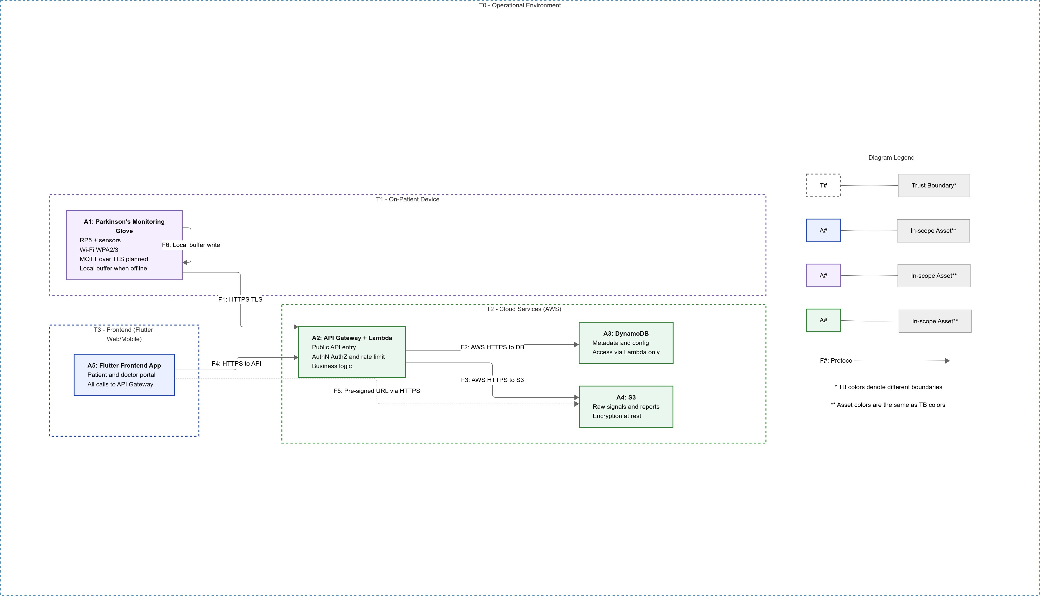

Fig. 1. Overall MeDUSA system architecture spanning on-device sensing, FluNer frontends, and AWS backend.

The system is further required to maintain availability under realistic conditions such as intermittent connectivity, cloud load spikes, or adversarial disruption attempts, so that clinical workflows are not delayed or denied. To enforce proper access, MeDUSA incorporates strong authenticity and authorization guarantees via JWT-based identity binding, refresh-token rotation, and IAM-enforced least-privilege policies for patients, clinicians, administrators, and devices. Finally, traceability is treated as a first-class objective: comprehensive audit logging of authentication events, data access, uploads, and administrative actions enables postmarket investigation, incident response, and regulatory compliance verification.
Together, these objectives map to the NIST SP 800-53 control families (e.g., AC, AU, SC, IA) and ISO/IEC 27001 Annex A requirements, providing a defensible standards-based foundation for the architecture described in subsequent subsections.
    - Adversary Model. The MeDUSA threat model considers adversaries operating across multiple layers of the system. Remote network attackers may attempt to intercept, replay, or modify API traffic, exploit input-validation weaknesses, or abuse public cloud endpoints through automated probing. At the client layer, compromised or malicious devices (e.g., rooted smartphones, modified Flutter apps, or stolen accounts) can attempt privilege escalation or unauthorized access to patient data.
Within the cloud environment, adversaries may target IAM misconfiguration, Lambda execution roles, or storage policies to escalate privileges, tamper with DynamoDB records, or extract cryptographic secrets. Proximal wireless attackers present additional risks during provisioning or telemetry transfer, including BLE-based onboarding exploitation, Wi-Fi impersonation, and manipulation of MQTT-style data channels. Finally, MeDUSA accounts for supply-chain and

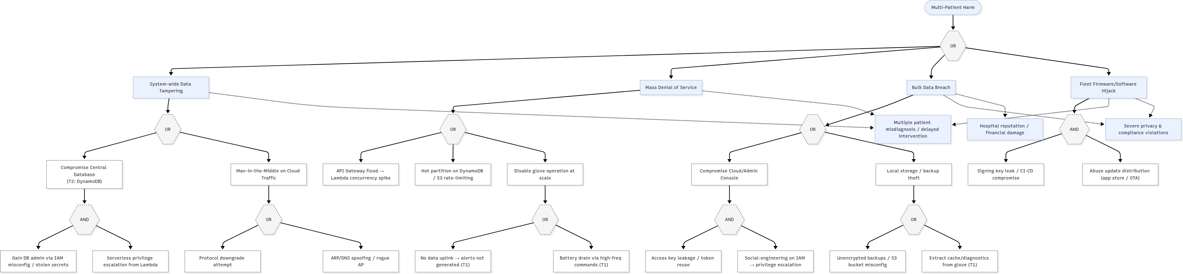

Fig. 2. System-wide hazard pathways and top-level threat scenarios for MeDUSA, derived from FDA/MITRE medical device threat modeling guidance.

ML-focused adversaries who may seek to poison training data, insert backdoors into model artifacts, or alter inference outputs to bias clinical outcomes. This heterogeneous adversary landscape motivates a defense-in-depth architecture spanning hardened firmware, authenticated channels, least-privilege cloud access, encrypted storage, and continuous monitoring.
    - Top-Level Threat Scenarios. Following the FDA/MITRE Medical Device Threat Modeling Playbook, we identify system-wide hazards that could lead to patient harm or compromised clinical operations. Figure 2 summarizes the most consequential pathways, including large-scale data compromise caused by cloud misconfiguration, undetected tampering of telemetry or reports leading to misdiagnosis, denial-of-service conditions that prevent timely clinician access, and fleet-wide firmware or ML pipeline hijacking that enables persistent manipulation of device outputs. These top-level scenarios guide the detailed security mechanisms presented later, particularly backend authorization logic, session and token management, secure file handling, and audit-based anomaly detection.

End-to-End Data Flow and Trust Boundaries
To support the security and functional requirements of a modern connected medical device ecosystem, MeDUSA implements a structured end-to-end data flow that spans three primary trust zones: the on-patient embedded subsystem (T1), the mobile and web application layer (T3), and the cloud services environment (T2). Understanding how data moves across these domains is essential not only for analyzing threat exposure but also for identifying the enforcement points at which authorization, integrity validation, and audit logging occur.
At the device layer (T1), physiological motion signals are generated by inertial sensors attached to a Raspberry Pi 5 running a hardened lightweight Linux distribution. The device aggregates raw sensor readings into short time windows, performs minimal preprocessing, and prepares payloads for secure transfer. Because the device resides in an untrusted physical environment and may be exposed to network manipulation, its outbound communication is designed to be strictly authenticated and encrypted, with no inbound connectivity to reduce the attack surface.
Once data enter the application layer (T3), represented by the Flutter-based patient and clinician portals, the system transitions from a constrained embedded environment to a user-facing software interface capable of session management, access control enforcement, and structured request generation. All communications between T3 and the backend traverse authenticated HTTPS channels that terminate at the API Gateway boundary. This layer is responsible for attaching identity claims, invoking token refresh workflows when necessary, and issuing upload or download requests using pre-signed URLs for larger artifacts such as pose videos or clinician report attachments.

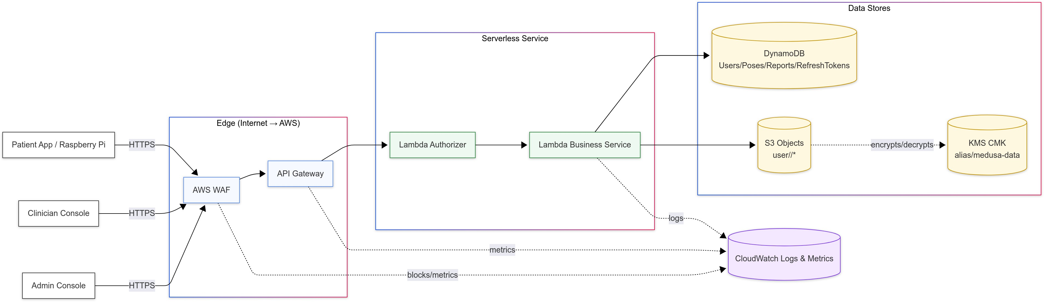

Fig. 3. Level-0 data flow diagram illustrating the movement of telemetry and clinical data across trust boundaries (T1: Device, T3: App, T2: Cloud).

The cloud services domain (T2) forms the core of MeDUSA’s security enforcement. Upon arrival at the API Gateway, incoming requests first pass through schema validation and API-level rate limiting before being forwarded to the Lambda authorizer. The authorizer validates JWT signatures, checks token freshness and revocation state, and applies fine-grained authorization rules derived from clinician–patient assignments and user roles. Only after an incoming request is authenticated and authorized does the system forward it to the corresponding service-specific Lambda function for processing. These backend functions implement application logic such as pose creation, report generation, or file-key management, and they mediate all access to DynamoDB and S3 storage.
Figure 3 provides a Level-0 data flow representation, illustrating the high-level movement of telemetry from the device to the cloud and onward to clinician-facing applications. The diagram highlights the separation of trust boundaries and clarifies that direct communication occurs only between adjacent layers, never bypassing authorization logic in the cloud. Figure 4 expands this into a Level-1 view, detailing how requests traverse specific backend services and where security controls such as API verification, token validation, and storage encryption are enforced.
The structured separation between T1, T3, and T2 ensures that each domain can enforce its own minimal and clearly defined responsibilities. The device focuses on reliable sensing and authenticated outbound transmission; the application layer mediates user interactions and session handling; and the cloud environment centralizes authentication, authorization, storage governance, and audit generation. By architecting MeDUSA around these explicit trust boundaries and well-defined data flows, the system reduces cross-domain attack vectors and enables the backend to serve as the authoritative enforcement point for security-critical decisions.

Cloud and Application Security Architecture
The cloud and application security layer forms the central enforcement point for identity management, authorization, data integrity, and auditability within MeDUSA. Whereas the embedded subsystem operates in a constrained and physically exposed environment, the cloud backend must defend against a significantly broader set of adversarial behaviors, support multi-party clinical workflows, and provide traceable, standards-aligned security guarantees. To meet these requirements, MeDUSA adopts a serverless architecture that leverages tightly scoped API boundaries, cryptographically protected storage, and auditable execution environments. Before describing the individual mechanisms in detail, we first motivate the technological choices that shape this layer.

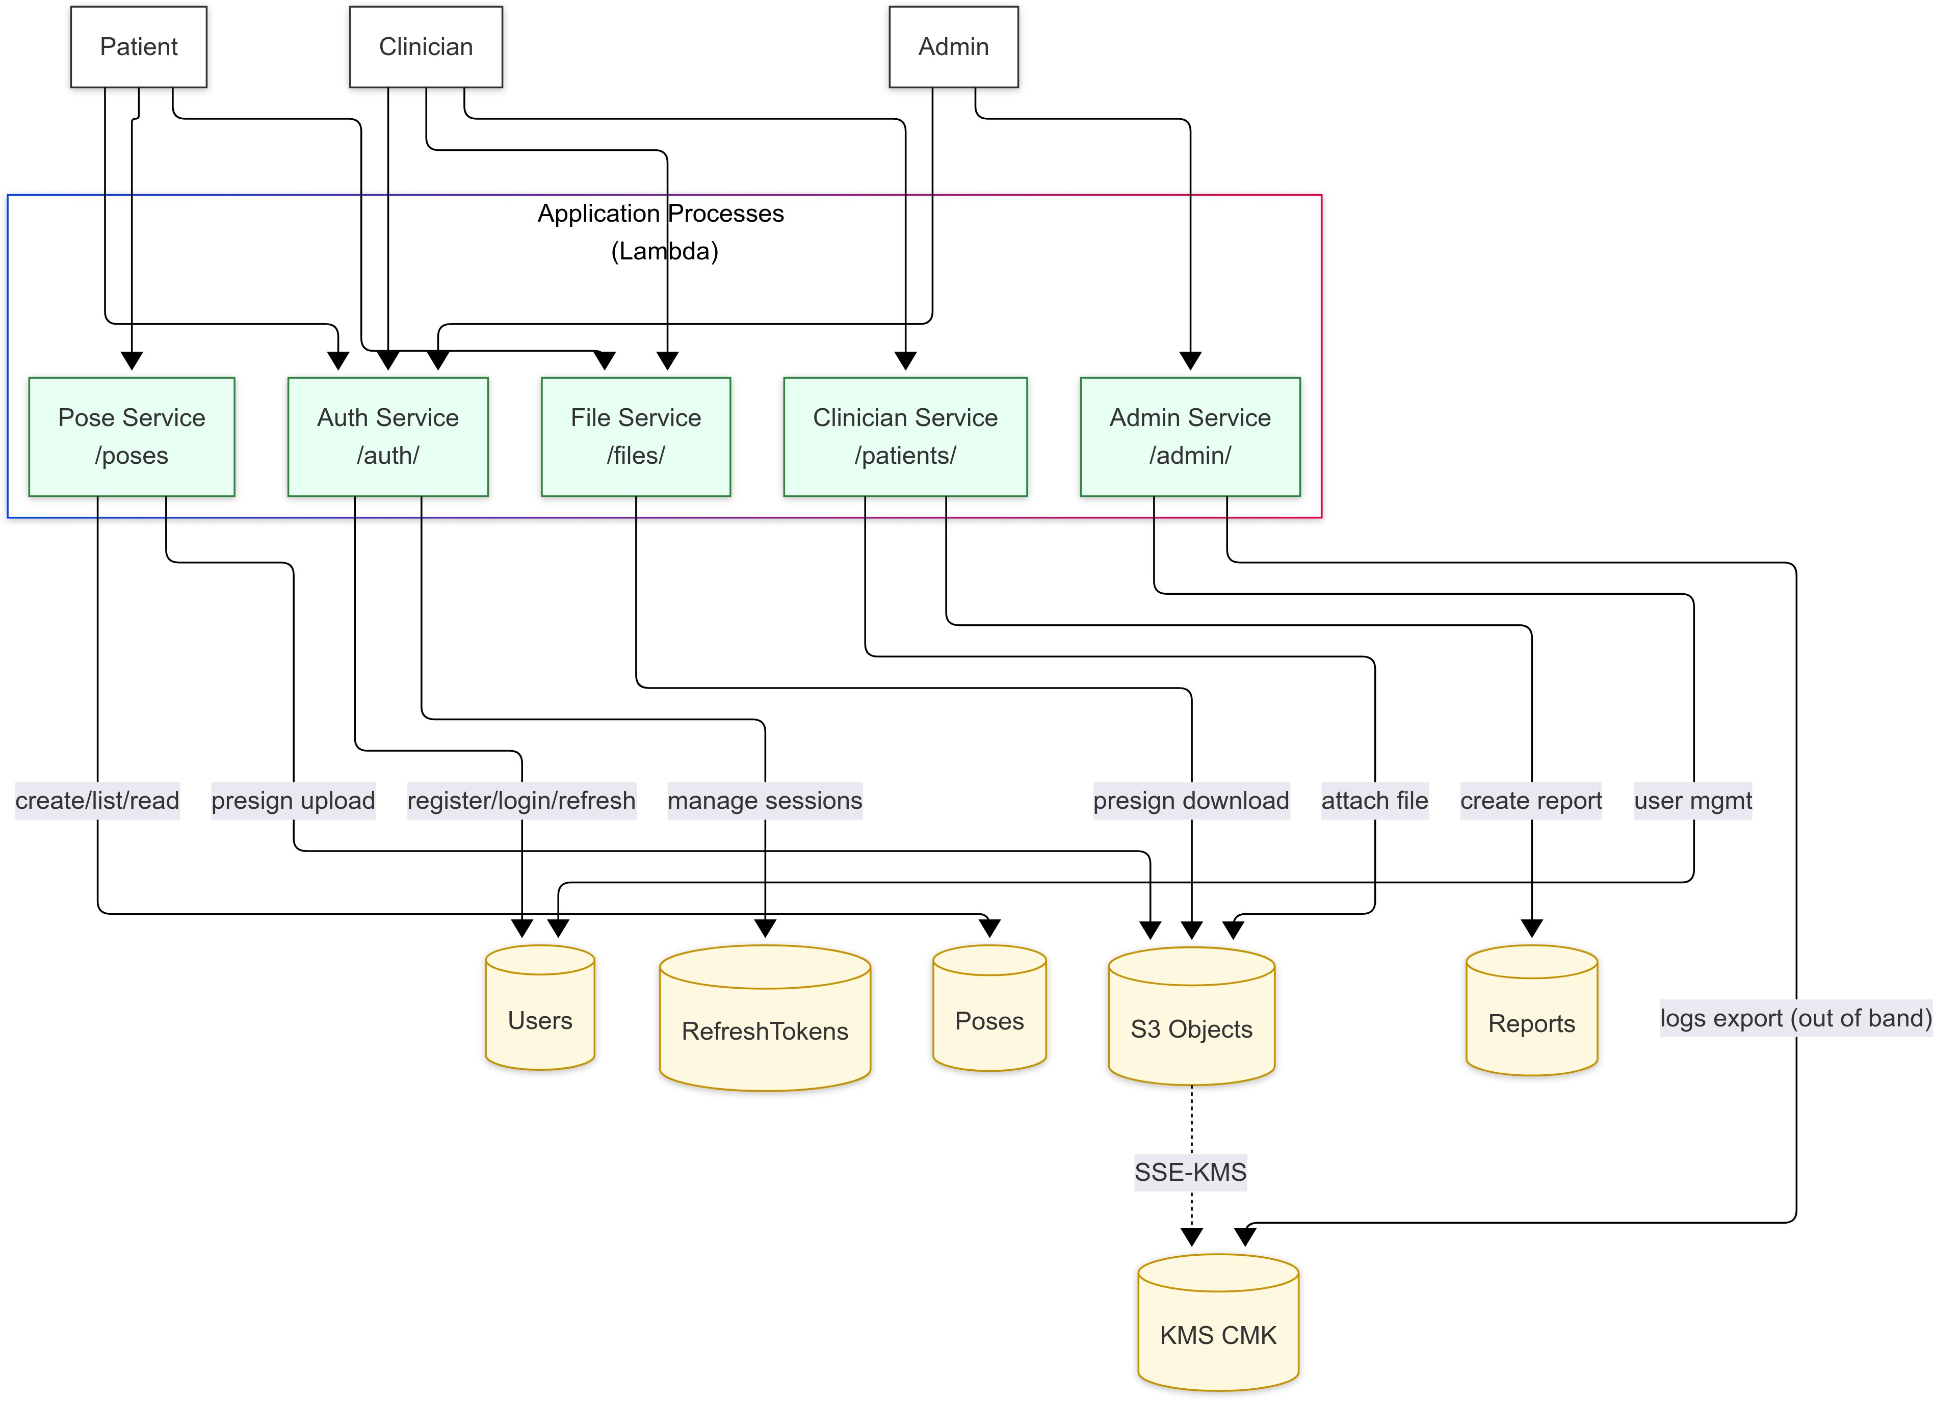

Fig. 4. Level-1 data flow diagram showing the security checkpoints and service interactions across API Gateway, Lambda authorizer, backend Lambda functions, and storage services.

    - Platform Choices: AWS and FluFer. Amazon Web Services (AWS) and Flutter were selected as the foundational platforms for the backend and client application layers not only for development practicality, but also for their security properties and alignment with regulatory expectations. AWS provides a mature security model rooted in least-privilege IAM governance, managed key infrastructure, and isolation guarantees across services such as API Gateway, Lambda, DynamoDB, S3, and KMS. Its serverless paradigm eliminates long-lived servers, reduces operational exposure, and enables deterministic, policy-driven behavior—features that map directly to FDA requirements for configuration transparency, reproducibility, and attack-surface minimization in cloud-connected medical devices.
Flutter complements this backend architecture by offering a unified, cross-platform application framework with strong security controls. Mobile applications built with Flutter operate inside platform-level sandboxes, support secure storage for credentials, enforce certificate validation, and maintain clear separation between user-interface logic and backend communication. By routing all network interactions through a consolidated HTTPS client abstraction—with consistent token handling, backend provenance checks, and optional certificate pinning—Flutter reduces the risk of platform-specific inconsistencies that often undermine security in heterogeneous client ecosystems.
Together, AWS and Flutter establish a coherent, defense-in-depth foundation: AWS functions as the authoritative policy, identity, and data-protection layer, while Flutter ensures that all client interactions with the cloud respect authenticated pathways and consistent security semantics. These platform choices shape the cloud and application security architecture described in the following subsections.

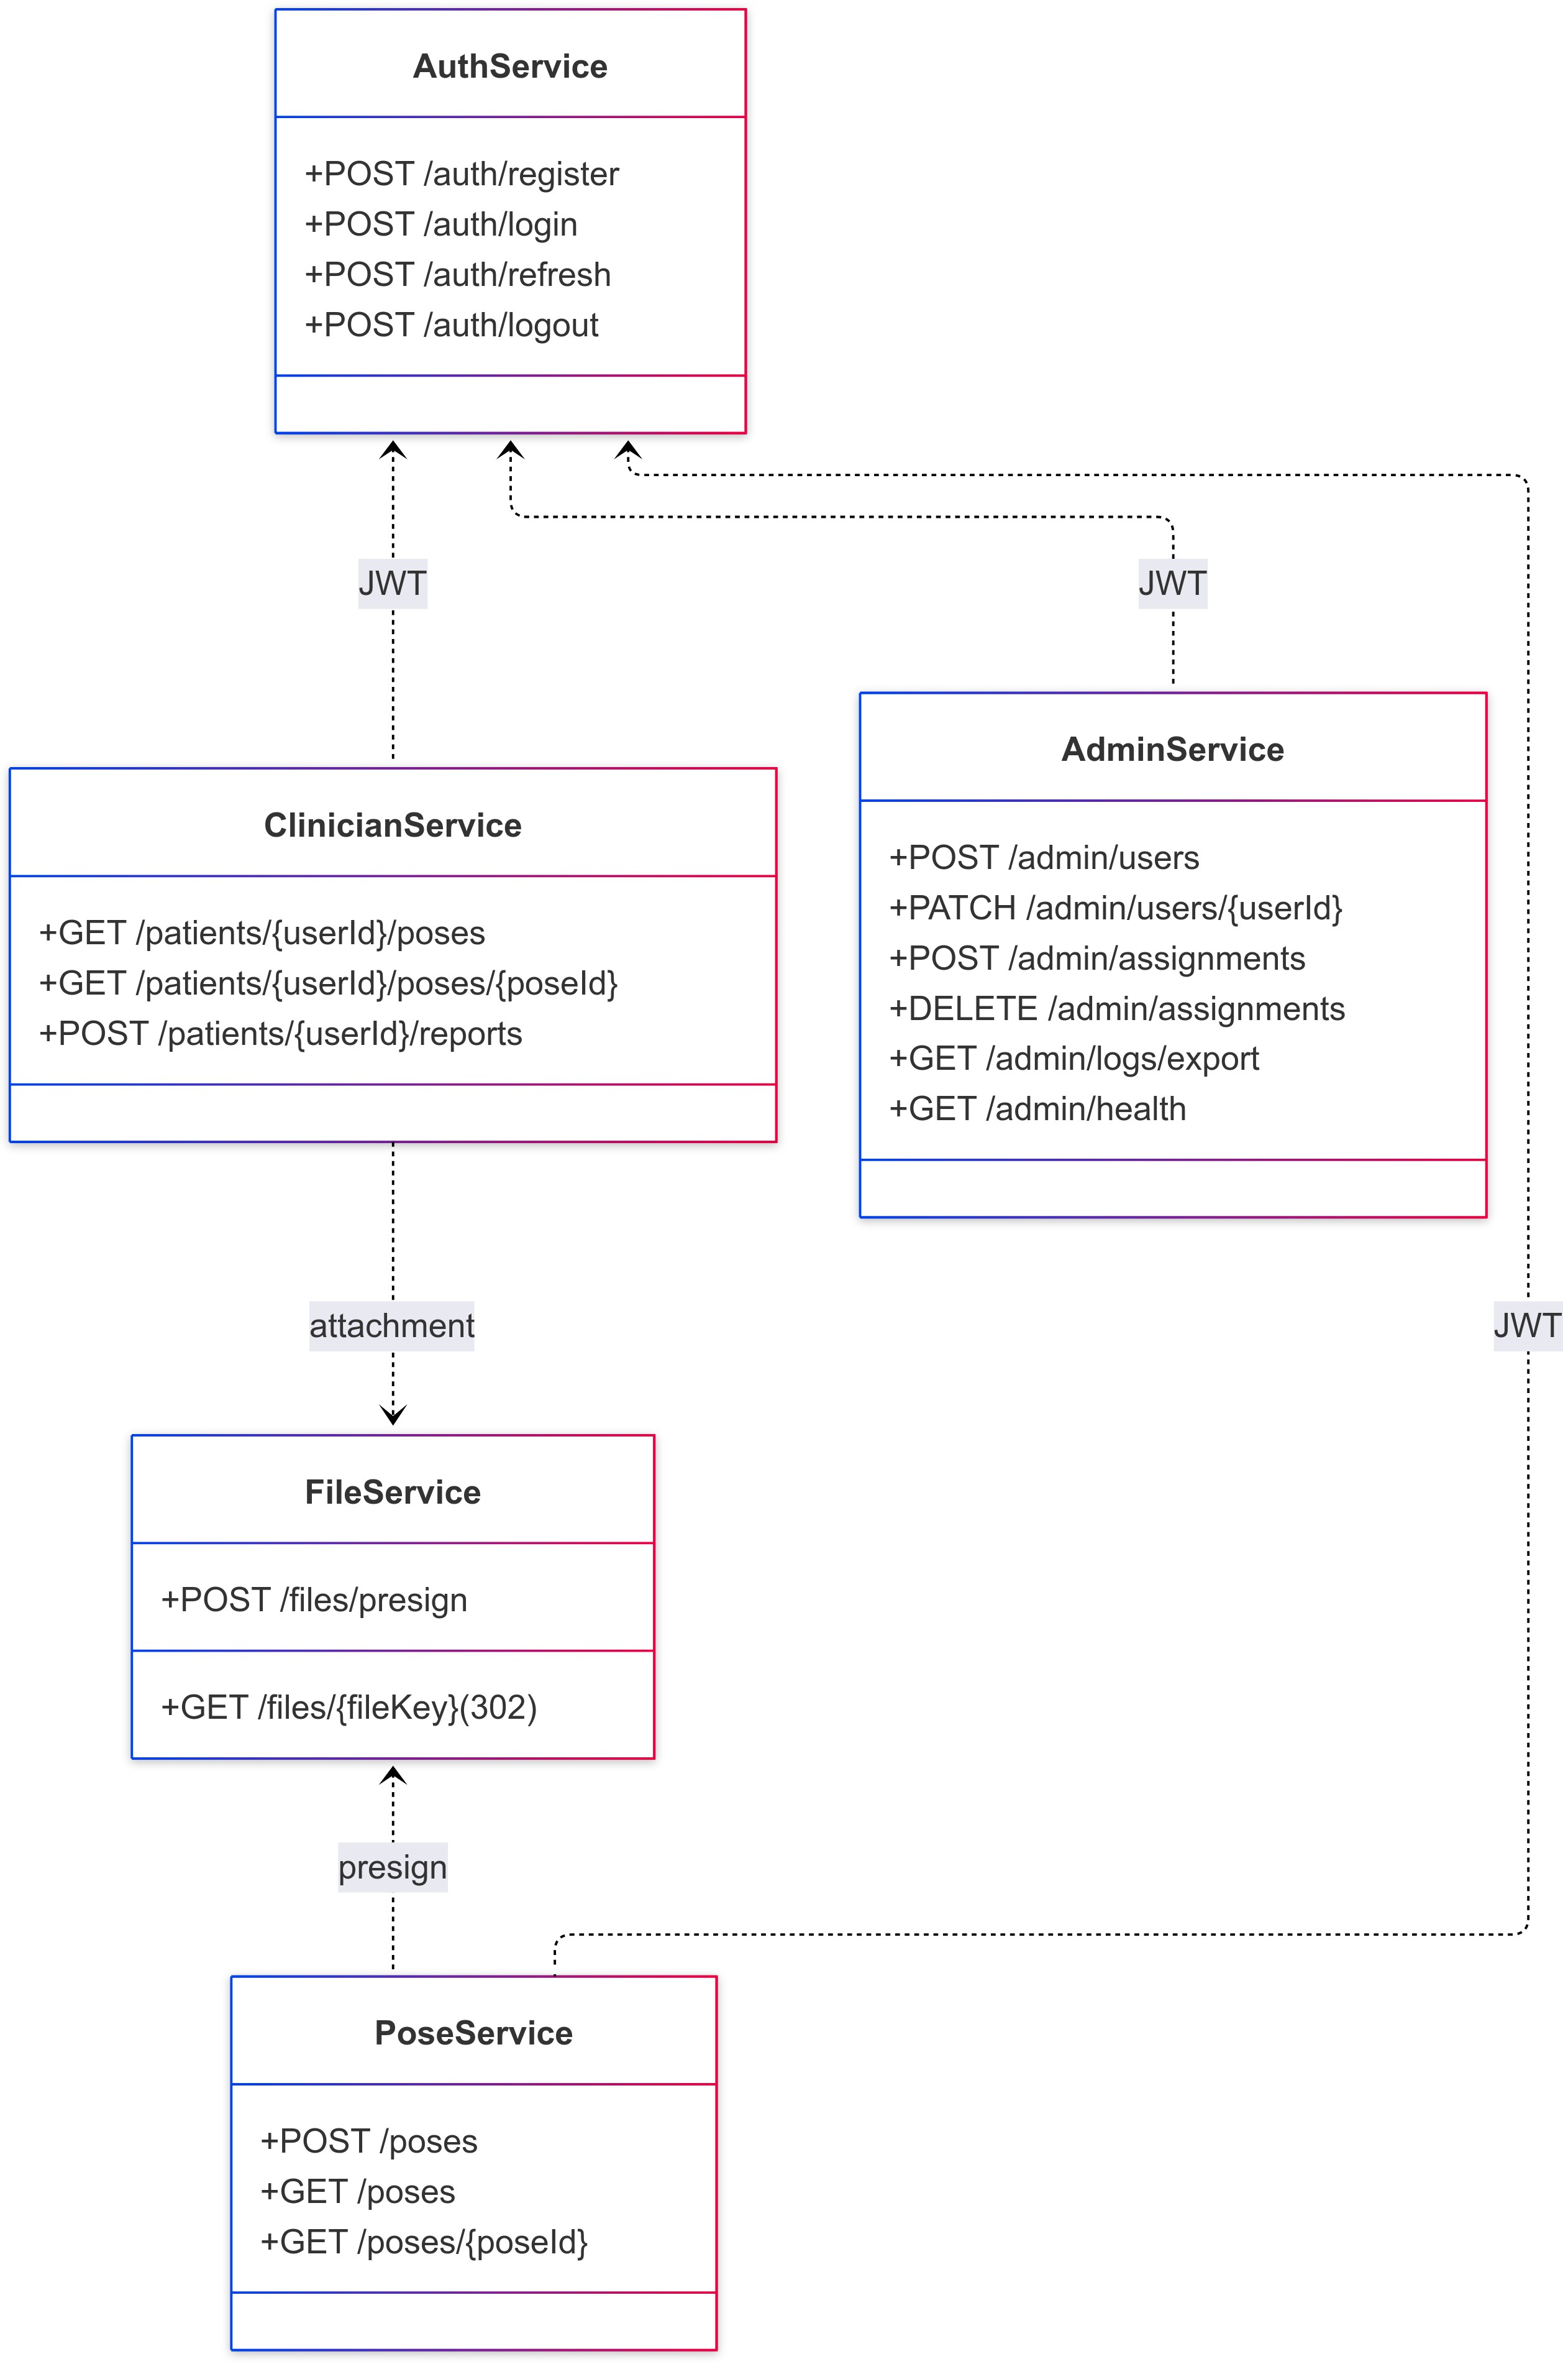

Fig. 5. Service-partitioned API surface for the MeDUSA cloud backend. Each service domain encapsulates narrowly scoped responsi- bilities to enforce least privilege and prevent cross-service escalation.

    - API Surface and Service Partitioning. The MeDUSA backend exposes a structured API organized into five logical service domains: AuthService, PoseService, FileService, ClinicianService, and AdminService. These service groups represent distinct security and functional responsibilities, preventing privilege creep and enabling fine-grained policy enforcement. Figure 5 illustrates the complete API surface, showing how each route corresponds to a specific Lambda function and tightly scoped DynamoDB or S3 operation.
Service partitioning plays a critical security role. The AuthService subsystem governs all session creation and refresh workflows; PoseService mediates patient-uploaded motion artifacts; FileService handles pre-signed URLs for S3 uploads and downloads; ClinicianService enforces clinician–patient assignment rules; and AdminService provides strictly controlled administrative management endpoints. Because each domain has a separate Lambda execution role, the blast radius of any single compromise is constrained by IAM restrictions, allowing the cloud layer to behave as a set of mutually isolated micro-boundaries.
    - Identity, Authentication, and Authorization. Identity management forms the backbone of the cloud security model. All access to protected endpoints requires a valid JSON Web Token (JWT) issued by the AuthService upon successful login. The token contains role claims (patient, clinician, administrator), the user identifier, and a token identifier (jti) used for server-side revocation. A companion refresh token, stored in a dedicated DynamoDB table, enables session continuity without prolonging the lifetime of access tokens.

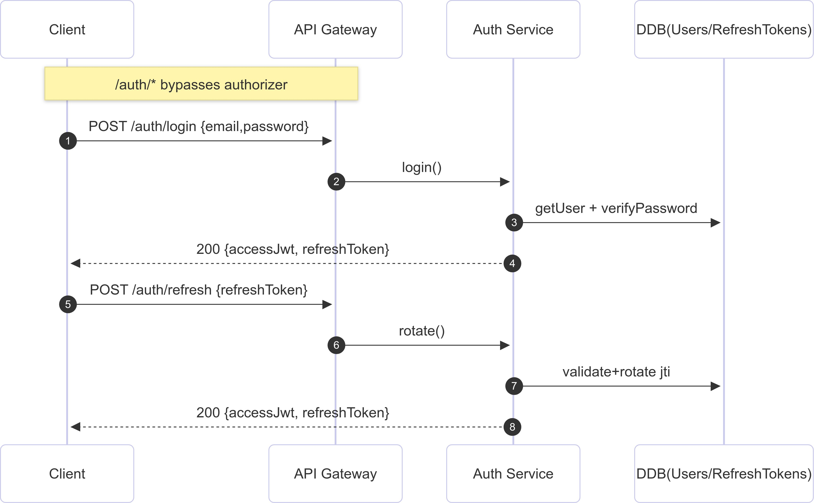

Fig. 6. Authentication and refresh-token rotation workflow. Authorization checks occur at the Lambda authorizer boundary, ensuring token freshness and revocation enforcement.

The authentication workflow is shown in Figure 6. To authenticate, the API Gateway routes the login request to the AuthService, which verifies credentials and returns a short-lived access token and a longer-lived refresh token. All non-auth routes subsequently pass through a Lambda authorizer that validates the token signature, checks token freshness, and queries the refresh-token store to ensure the jti has not been revoked. This approach allows the backend to enforce immediate revocation, a critical requirement for healthcare contexts in which lost devices or compromised accounts must be disabled without delay.
Authorization builds on identity verification by applying role- and relationship-based rules. For example, a clinician may only access pose data for patients explicitly assigned to them, while patients can upload pose data only for themselves. These constraints are enforced within the Lambda authorizer, ensuring that no backend Lambda function receives a request for which the caller lacks explicit permissions. By centralizing authorization logic at this boundary, the system guarantees consistent, deterministic enforcement across all services.
    - Data Model and Access Governance. The data model, shown in Figure 7, is designed to reflect the real-world relationships between users, clinical artefacts, and session state. The model includes four core entities: Users, Poses, Reports, and RefreshTokens. Each entity is stored in a dedicated DynamoDB table with strict IAM policies binding specific Lambda functions to specific read or write operations.
This data organization supports several key security properties. First, ownership relationships are explicit: every pose and report references a single userId, guaranteeing traceability and simplifying authorization checks. Second, clinician–patient assignment is represented as an attribute of user profiles, enabling assignment-based authorization without maintaining separate mapping tables. Third, refresh tokens include metadata such as IP address, user agent, and creation timestamp, enabling anomaly detection and raising the bar against token abuse.

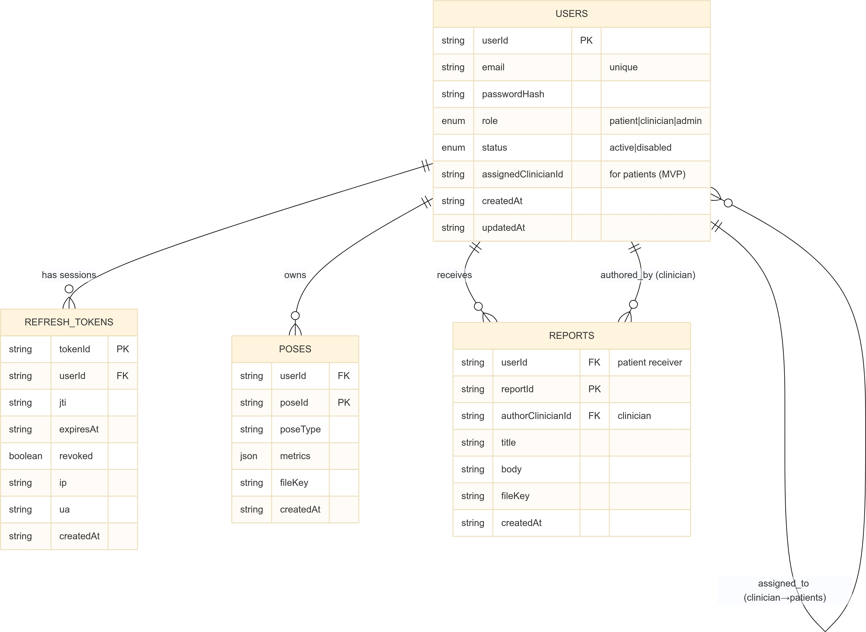

Fig. 7. Logical data model of MeDUSA, showing user roles, pose ownership, clinician–patient relationships, and session state.

    - Secure File Handling and Pre-Signed URL Management. Because pose uploads and report attachments can be large binary artifacts, they are stored in Amazon S3 rather than DynamoDB. Direct S3 access is never granted to clients; instead, FileService issues short-lived pre-signed URLs that encode specific object keys and upload permissions. Figure 8 illustrates the upload workflow, in which the backend first verifies the caller’s authorization, generates an S3 upload URL, and records the metadata necessary to link the uploaded file to the appropriate user.
All stored objects are encrypted using AWS KMS (SSE–KMS). The encryption key (a customer-managed CMK) is restricted such that only the specific Lambda execution roles may invoke encryption or decryption operations. This prevents privilege escalation attacks involving stolen credentials or misconfigured IAM roles. Additionally, S3 bucket policies explicitly forbid public access, cross-account access, or direct GET requests without a valid pre-signed URL.
File integrity is maintained by storing metadata—such as fileKey, creation time, and poseId or reportId—in DynamoDB. This separation ensures that a tampered or unauthorized file in S3 cannot be associated with a clinical record without detection.
    - Service Execution Model and Runtime Isolation. Each backend service executes inside a short-lived Lambda container, providing strong isolation between requests. Lambda functions run with minimal environment variables, no writable filesystem except for the ephemeral /tmp directory, and no ability to invoke AWS APIs beyond those permitted by their role. This model significantly reduces the feasibility of cross-service compromise: even if an attacker gains control of one Lambda function, they cannot access data owned by another service or escalate IAM privileges.
The sequence-flow diagram in Figure 9 demonstrates this isolation during a clinician report creation. Each step—authorization, pre-signed URL issuance, metadata recording, and file upload—runs in a distinct Lambda function

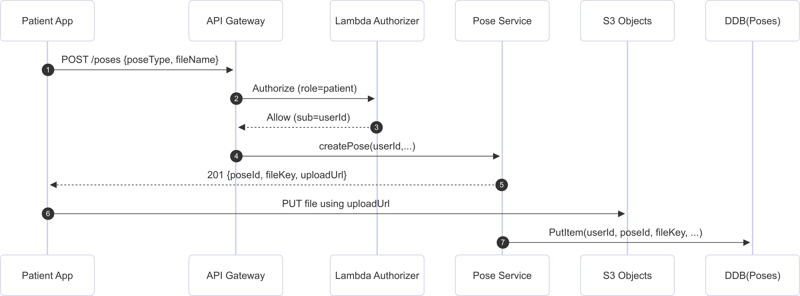

Fig. 8. Pose upload workflow using pre-signed URLs. The backend enforces identity and authorization before allowing any S3 interaction.
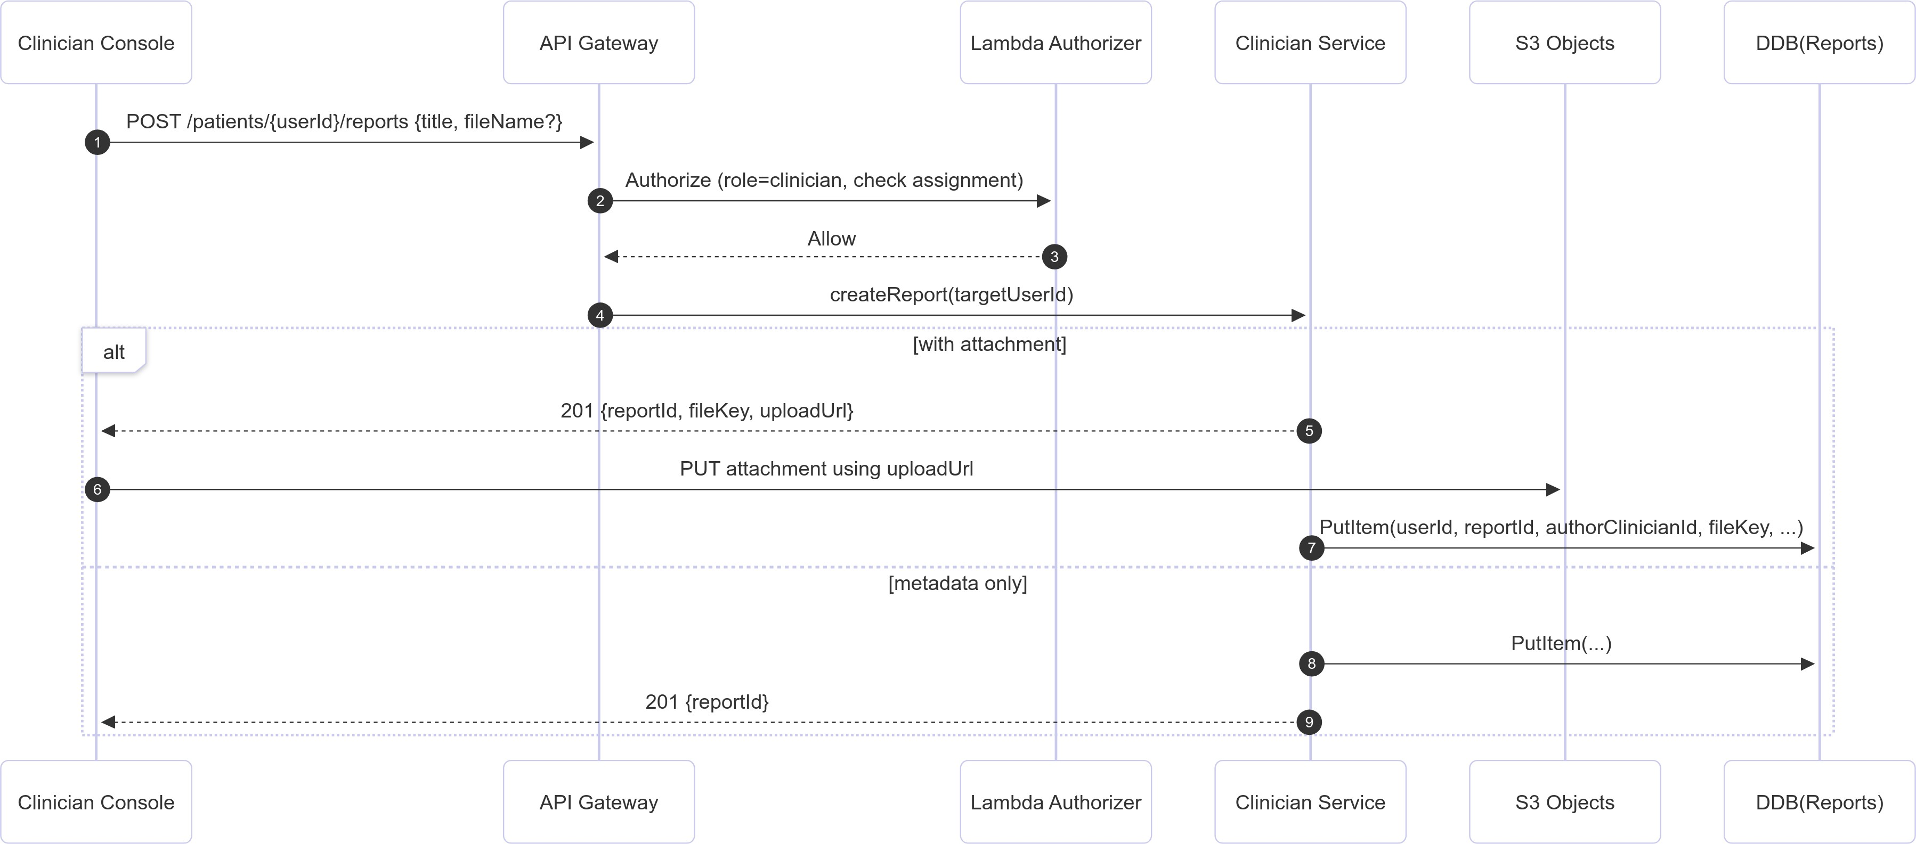

Fig. 9. Report creation workflow showing authorization checks, S3 upload isolation, and metadata recording by separate Lambda functions.

with its own permissions. The clinician-facing application never interacts directly with DynamoDB or S3, and all operations are mediated by strictly scoped backend functions.
3.4./ Audit Logging, Monitoring, and Postmarket Security. All API interactions, authorization outcomes, and backend operations generate structured CloudWatch logs containing timestamps, caller context, request identifiers, and policy- evaluation results. These logs form an immutable audit trail essential for regulatory compliance and postmarket investigation. Metrics such as 4XX/5XX response rates, latency percentiles, and login failure patterns are aggregated for anomaly detection, enabling early detection of credential misuse, API probing, or distributed denial-of-service patterns.

Table 1. Mapping of MeDUSA security objectives to regulatory and standards-aligned technical controls.

Security Objective MeDUSA Mechanisms NIST SP 800-53 Families ISO/IEC 27001 Annex A Controls FDA Premarket Expectations

Confidentiality IAM-scoped access to DynamoDB and S3; TLS 1.3 enforce- SC; MP. A.8; A.10; A.13. Use of modern encryption; secure communi-
ment; KMS-backed encryption for stored artifacts. cation paths; protection of PHI.
Integrity Hash-verified metadata; deterministic validation; tamper- SI; AU. A.12; A.14. Integrity verification of telemetry and clinical

resistant logs; structured pose/report linking.
outputs; prevention of undetected modifica- tion.

Availability Serverless auto-scaling; API Gateway rate limiting; isolated CP; SC; AC. A.17; A.13. Continuity of clinical access under load/faults.
Lambda runtime.
Authenticity & Authorization JWT identity binding; refresh-token rotation with jti track- IA; AC. A.9; A.18. Strong authentication and role-appropriate au-
ing; IAM least privilege. thorization.
Traceability API Gateway access logs; CloudWatch structured logs; cor- AU; IR. A.12; A.16. Support for postmarket monitoring and foren-
relation IDs. sic reconstruction.

The monitoring stack supports the FDA’s postmarket cybersecurity expectations, particularly the need to detect anomalous device behavior, identify indicators of compromise, and maintain traceability of all clinical and administrative actions. Because Lambda functions are stateless and isolated, any anomalous execution sequence is immediately detectable through divergences in expected logging patterns.
3.4.8 Summary of Cloud Security Guarantees. The combined effect of service partitioning, strict IAM governance, authenticated data flows, encrypted storage, and continuous monitoring is a cloud security architecture that enforces defense-in-depth across all backend operations. Every interaction—whether originating from a patient uploading pose data, a clinician generating a report, or an administrator managing user assignments—passes through a consistent security boundary at the API Gateway and Lambda authorizer. This ensures that the cloud environment acts as the system’s authoritative policy engine and provides the guarantees necessary for safe, reproducible, and regulation-aligned medical device operation.

Security Controls Mapping to Regulatory and Standards Frameworks
Because MeDUSA aims to serve as a reproducible reference architecture for secure cloud-connected medical devices, it is important to articulate how the system’s technical controls correspond to established cybersecurity and regulatory frameworks. While the platform was not designed to achieve formal certification, its mechanisms intentionally align with key control families from NIST SP 800-53, ISO/IEC 27001 Annex A, and expectations in the FDA Premarket Cybersecurity Guidance. Table 1 summarizes this alignment across the core security objectives defined earlier in Section 3.2.
The mapping illustrates how high-level regulatory principles translate into concrete system behaviors—such as IAM-enforced least privilege, structured audit logging, deterministic access control, encryption at rest and in transit, and authenticated telemetry ingestion. This traceability helps narrow the regulatory-to-technical gap discussed in Section 2.4 and provides a foundation for systematic evaluation in Section 4.

Interaction with Embedded and Machine-Learning Subsystems
The MeDUSA architecture spans three distinct operational tiers—T1 on-device sensing, T2 cloud processing, and T3 clinician-facing interfaces—and therefore requires carefully structured interaction patterns across subsystem boundaries. Although each tier operates within its own trust domain, their communication paths must preserve end-to-end integrity and ensure that clinical decision-making is supported by authenticated, provenance-rich data flows. This subsection details how the embedded hardware and machine-learning components integrate with the cloud backend, the security expectations assigned to each tier, and the mechanisms used to preserve data lineage throughout the workflow.

On-device data acquisition occurs within T1, where the embedded subsystem collects motion signals via the Raspberry Pi 5 and attached sensors. The device executes lightweight preprocessing steps and performs temporary local buffering when connectivity is unavailable. While T1 does not operate in a fully trusted environment, its responsibilities are intentionally limited: it cannot directly modify patient metadata, access clinician assignments, or alter historical records. Instead, its only privileged interaction is the initiation of pose-upload requests, authenticated using device- bound credentials and constrained by role-based JWTs issued at registration time. This narrow responsibility reduces the consequences of device compromise and enforces a deterministic upward flow of telemetry.
Captured telemetry is ingested by T2, where machine-learning inference pipelines transform raw sensor streams into posture classifications and aggregated movement features. The ML layer interacts with the cloud backend through the same API surface as other components, ensuring that model outputs do not bypass authorization boundaries or introduce hidden data channels. Importantly, the ML subsystem must also be protected against poisoning or tampering, as manipulated feature vectors could propagate incorrect clinical assessments to downstream roles. MeDUSA mitigates these risks through metadata validation, structured report formats, and explicit linking of ML-derived artifacts to authenticated user identities. These measures ensure that inference results remain attributable, versioned, and auditable across the lifecycle of clinical interaction.
T3, the clinician-facing portal, consumes both raw metadata and ML-derived summaries to support real-time review, longitudinal tracking, and clinical documentation. Access to ML outputs is restricted to assigned clinicians, and cross-user inference browsing is explicitly forbidden by the backend. All clinician actions—including report authoring, reading patient history, and reviewing device-generated alerts—are logged within the audit subsystem to preserve traceability. This design ensures that while ML provides decision support, its results are always contextualized within an auditable clinical workflow rather than operating as an opaque or autonomous decision-maker.
Together, the interaction model across T1–T3 provides a principled foundation for integrating embedded hardware and machine-learning pipelines into a secure medical-device ecosystem. By enforcing narrow privileges in T1, authenti- cated ML processing in T2, and tightly scoped clinical access in T3, MeDUSA ensures that data retains integrity and provenance from initial capture to final clinical interpretation.

Comparative Analysis
To better contextualize MeDUSA’s cloud and application security architecture, it is instructive to compare the system against common patterns observed in contemporary connected medical devices and IoT health platforms. Traditional architectures frequently rely on monolithic backend servers, long-running virtual machines, or loosely governed microservice collections stitched together with inconsistent access control policies. These approaches tend to accumulate configuration drift, rely heavily on manual security patching, and expose broader attack surfaces through open network ports or overly permissive inter-service privileges. Their complexity can obscure data lineage and weaken the ability to trace or reconstruct security-critical events.
By contrast, MeDUSA adopts a deliberately minimalist and tightly governed model centered on serverless execution and explicit trust boundaries. The absence of long-lived servers eliminates entire classes of vulnerabilities associated with daemon persistence, operating-system misconfiguration, and unpatched runtime dependencies. Each Lambda function operates with an execution role restricted to a narrow set of operations, enforcing least privilege at a granularity rarely achievable in traditional infrastructures. The use of API Gateway as the sole public entry point provides a uniform barrier for rate limiting, schema validation, authentication, and request normalization—capabilities that are often fragmented across heterogeneous microservice deployments.

In addition, MeDUSA’s storage pipeline prioritizes deterministic access governance. DynamoDB tables are not exposed directly to internal or external services; all access is mediated by the backend, providing a single authoritative enforcement point for authorization and auditability. S3 object access is similarly restricted through pre-signed URLs with short expiration times, ensuring that file operations cannot bypass identity checks. Compared with architectures that rely on broad S3 bucket permissions or shared credentials to facilitate device uploads, MeDUSA’s design significantly reduces the risk of data exfiltration, unauthorized writes, or object-level tampering.
Finally, the system’s explicit separation of embedded, machine-learning, and cloud layers reinforces overall resilience. Each subsystem interacts with the next only through authenticated, documented, and auditable pathways, preventing implicit trust or silent cross-domain dependencies. This contrasts with many IoT health solutions in which device, application, and analytics pipelines share overlapping privileges or rely on opaque data transformations. MeDUSA’s structured separation enables reproducible evaluation, simplifies regulatory review, and increases transparency around both clinical and security-relevant behavior.
Collectively, this comparison highlights that MeDUSA’s security benefits derive not from isolated mechanisms but from the alignment of architectural choices, least-privilege design, and deterministic control over data flow. This positions the platform as a model for future cloud-connected medical devices seeking to balance functionality, scalability, and regulatory-aligned security guarantees.

Key Insights and Design Principles
Several overarching insights emerged during the design and implementation of the MeDUSA cloud and application architecture. Foremost is the recognition that secure behavior in medical device ecosystems cannot be achieved solely through strong cryptographic mechanisms or isolated hardening steps. Instead, security must be established through a coherent system-level design in which each component—the embedded subsystem, the ML pipeline, the client applications, and the cloud backend—participates in well-defined trust relationships and contributes to end-to-end integrity.
A second insight is the value of determinism in cloud security. By adopting a pure serverless model, MeDUSA avoids many sources of nondeterminism that complicate incident response and regulatory evaluation, such as variable server configurations, inconsistent application lifecycles, or environment drift. Lambda functions, IAM roles, and API Gateway definitions together form a declarative security perimeter that can be audited, reproduced, and verified. This determinism also simplifies the integration of anomaly detection and postmarket monitoring, since deviations from expected execution paths become immediately observable.
The project also revealed the importance of minimizing implicit trust between subsystems. The design enforces that data never bypass established authorization boundaries, even in internal service-to-service interactions. This principle prevents privilege escalation scenarios and ensures that ML outputs, device telemetry, and clinician-generated reports all undergo consistent validation before entering long-term storage or clinical workflows. The architecture thereby reduces the risk that a compromise in one subsystem propagates silently across others.
Finally, MeDUSA demonstrates that usability, robustness, and regulatory alignment are not competing objectives but can be achieved simultaneously through principled architectural design. The same mechanisms that simplify developer workflows—such as centralized authorization logic, pre-signed URL workflows, and schema-validated APIs—also enhance patient safety and improve auditability. This convergence suggests a path forward for future medical device platforms: by grounding design decisions in reproducibility, traceability, and least privilege, developers can construct systems that are both clinically useful and inherently resilient.

Together, these insights served as guiding principles throughout the design of MeDUSA and provide a foundation for future extensions of the system, including more advanced ML capabilities, expanded device classes, and enhanced postmarket security analytics.

Experimentation, Evaluation, and Result Analysis
  - Evaluation Objectives
The evaluation of MeDUSA is structured to reflect the security-by-design goals established in Section 3, with emphasis on correctness, deterministic enforcement, and traceability in a cloud-connected medical device setting. Unlike performance-centric system papers, our primary concern is not throughput maximization but rather whether security- critical workflows behave predictably under both normal and adversarial operating conditions. This framing aligns with regulatory expectations in medical-device cybersecurity, where mis-enforcement, silent failure, or inconsistent access-control decisions can directly affect clinical safety.
Concretely, the evaluation targets three complementary objectives. First, it validates that core clinical workflows are secure-by-default. These workflows include patient data uploads, clinician retrieval of longitudinal pose records, report authoring and attachment handling, and administrative user/assignment management. For each workflow, we examine whether the backend enforces intended identity and authorization constraints, and whether the resulting artifacts preserve integrity and provenance throughout storage and retrieval cycles. This objective ensures that routine clinical usage does not inadvertently create unsafe states or unauthorized data exposure.
Second, we evaluate MeDUSA’s resistance to plausible adversarial behaviors that arise in cloud-connected device ecosystems. Rather than simulating full-spectrum red-team operations, we focus on high-likelihood misuse patterns consistent with FDA/MITRE threat guidance. These include malformed or forged JWTs, replayed refresh tokens, reuse of expired pre-signed URLs, cross-role privilege escalation attempts, and cross-resource access violations. The goal is to confirm that security boundaries fail closed, and that enforcement decisions are derived from backend policy rather than client-side assumptions.
Third, we assess whether the system’s observability mechanisms provide sufficient evidence for postmarket cybersecurity management. A key requirement for medical-device platforms is the ability to reconstruct security- relevant events after deployment, including identifying unauthorized actions, determining the scope of affected data, and supporting incident-response timelines. Therefore, even in cases where access is denied, the evaluation checks that the backend produces clear and attributable log traces. This objective is essential for future integration of automated monitoring pipelines and supports the broader reproducibility goals of MeDUSA.
Together, these objectives position the evaluation as a direct verification of MeDUSA’s architectural principles: least privilege across services, explicit trust boundaries, deterministic enforcement, and audit-first workflow design. The following subsections describe the experimental environment and the specific validation procedures used to satisfy these objectives.

Experimental Setup
Experiments were conducted on the deployed MeDUSA serverless backend hosted on AWS, with client interactions issued through both the Flutter application and direct HTTP tooling. This dual approach ensures that observed behavior reflects backend enforcement rather than client-side filtering. All API calls were routed through API Gateway and, except for authentication endpoints, passed through the Lambda authorizer. Backend services were implemented as

isolated Lambda functions, each bound to a dedicated IAM execution role scoped to the minimal DynamoDB and S3 operations required for its domain. Database state was maintained in DynamoDB tables corresponding to users, poses, reports, and refresh-token sessions, while binary artifacts were stored in S3 buckets protected with SSE-KMS.
To preserve repeatability, we executed validation procedures against a controlled set of test accounts representing the three supported roles: patient, clinician, and administrator. Patients were provisioned with unique identifiers and associated pose-upload permissions; clinicians were assigned to specific patient subsets; and administrators were granted management endpoints for user state changes and assignment updates. This role graph enabled systematic testing of authorization boundaries, particularly when exercising cross-user and cross-role access attempts. All experiments used short-lived access tokens paired with refresh tokens to model realistic session continuity.
Workflow validation was executed in two modes. In the first, we used the Flutter client to perform normal end-user tasks such as login, pose uploads via pre-signed URLs, clinician retrieval of pose history, and report authoring. In the second, we reproduced these same requests through direct HTTP clients (e.g., curl/Postman) and manually altered parameters to evaluate policy enforcement under off-path behavior. This method surfaces discrepancies that might otherwise be masked by client-side UI constraints, and reflects realistic adversarial contexts where attackers interact with public API surfaces directly.
Adversarial and boundary-condition tests were designed to mirror the threat assumptions introduced in Section 3.2. JWT tampering tests modified token headers, claims, and signatures to confirm authorizer rejection. Replay tests reused expired refresh tokens and stale pre-signed URLs to validate rotation logic and temporal constraints. Cross-resource access tests attempted to read or mutate artifacts outside a requester’s ownership or clinical assignment. Finally, malformed requests—including truncated JSON bodies and unsupported parameter combinations—were injected to verify fail-closed behavior and stable error handling. For all such cases, we recorded both user-visible outputs (HTTP codes, response bodies) and backend-visible traces (CloudWatch logs, API Gateway access logs).
Throughout evaluation, we treated the backend as the authoritative security boundary. No test was considered successful unless its outcome was enforced server-side with consistent logging evidence. This setup is appropriate for medical-device deployments where clients may be rooted, modified, or replaced entirely, and where safety depends on invariant backend enforcement rather than trusted user applications. Subsequent sections report the validation procedures and observed behaviors under this configuration.

    - Test Case Inventory. To guide the evaluation activities described in subsequent sections, we enumerated a structured inventory of test cases covering the major security-relevant workflows of the MeDUSA platform. The intent of this inventory is not to report outcomes, but rather to document the scope of behaviors that require verification in a reproducible, cloud-connected medical-device system. Each test case targets a specific interaction pattern between the client applications, the API Gateway, and the serverless backend, ensuring that the evaluation remains aligned with both the threat model defined in Section 3.2 and the architectural guarantees articulated in Section 3.4.
The inventory spans five categories of interest: identity and session management, authorization boundaries across roles, secure file-handling processes, telemetry upload workflows, and administrative operations. Within each category, the test cases focus on verifying not only functional correctness but also the security properties that underpin reliable clinical workflows. This organization provides a systematic pathway for assessing whether the backend exhibits deterministic policy enforcement, produces consistent audit artifacts, and rejects malicious or malformed requests in a manner that is both predictable and traceable. The table below summarizes the principal test categories and the corresponding behaviors each is intended to validate.

Table 2. Representative inventory of test categories and associated security properties for evaluation.

Test Category | Representative Endpoints / Workflows | Security Property Validated
Identity & Session Manage- | /auth/login, /auth/refresh, rotation of re- | Correct JWT issuance; refresh-token rota-
ment | fresh tokens | tion; rejection of malformed or expired to-
 |  | kens; stable identity binding.
Role-Based Authorization | Patient view of /poses; clinician access to as- | Enforcement of least privilege; prevention
 | signed patients; admin user/role management | of cross-role data access; deterministic re-
 |  | jection of unauthorized actions.
Pre-Signed File Handling | /files/presign; S3 PUT using temporary | Correct generation of pre-signed URLs;
 | credentials; metadata persistence in Dy- | scope-limited permissions; integrity link-
 | namoDB | age between uploaded files and metadata
 |  | entries.
Pose Upload Workflow | /poses creation with file attachment; confir- | Authenticated data submission; upload cor-
 | mation of pose metadata; audit-log correlation | rectness; metadata completeness; traceabil-
 |  | ity of user actions across services.
Clinician Report Workflow | /patients/{id}/reports; optional file at- | Assignment-based authorization; binding of
 | tachment; clinician-only access | report artifacts to patient identity; rejection
 |  | of cross-account report creation.
Administrative Operations | /admin/users, /admin/assign, role updates; | Correct enforcement of RBAC for admin-
 | export of system logs (metadata only) | istrative functions; log accessibility bound-
 |  | aries; prevention of privilege escalation.

Taken together, these test categories ensure that the evaluation covers the full spectrum of interactions relevant to MeDUSA’s cloud and application security guarantees. They also provide a foundation for the adversarial and boundary- condition tests presented in Section 4.4, as well as a consistent framework for reporting results once the test suite is fully executed.

Functional Validation of Secure Cloud Workflows
Validating the correctness of MeDUSA’s cloud security mechanisms requires exercising each backend workflow under realistic interaction patterns. Because the architecture relies on a combination of tightly scoped Lambda functions, role-based authorization rules, and short-lived session credentials, the evaluation emphasizes whether these controls behave predictably in everyday use. The tests were conducted using the production deployment, not a local emulator, in order to capture the system’s true behavior under API Gateway, IAM, and S3 enforcement.
A substantial portion of this evaluation focused on authentication and session management. We tested login flows under multiple credential scenarios—valid, malformed, expired, and deliberately altered JWTs. In the normal case, the AuthService correctly produced a signed access token and a refresh token with the expected expiration profile. When presented with expired or syntactically invalid tokens, the Lambda authorizer rejected the requests immediately and recorded the failure in CloudWatch logs with the proper error classification. These early-stage checks ensure that the security boundary at API Gateway remains intact.
Authorization correctness was evaluated by having different user roles attempt actions outside their allowed scope. Patients were restricted to operations involving their own records, and our tests confirmed that cross-account reads or writes were rejected consistently. Clinicians attempting to access patients not assigned to them received a
deterministic 403 Forbidden response, and the access attempts were logged with sufficient detail to support post- incident reconstruction. Administrative functions were tested separately, since errors in privilege boundaries at this

Table 3. 3 validation summary across API domains.

API Group Endpoints Tested Security Property Vali-
dated
Outcome

AuthService /auth/login,
/auth/refresh
Token issuance, rotation, re- vocation; malformed JWT rejection
PASS

PoseService /pose/create, /pose/list Ownership enforcement;
metadata integrity; cross- account isolation
PASS

FileService /file/upload-url,
/file/get-url
Pre-signed URL validity; ex- piration behavior; identity binding
PASS

ClinicianService /clinician/report/create Assignment-based au-
thorization; rejection of unassigned-patient access
PASS

AdminService /admin/assign, RBAC enforcement; privi-
/admin/update-role lege boundary correctness
PASS

layer would have disproportionate impact. The AdminService correctly enforced narrow permissions for role updates and assignment changes, blocking all non-admin callers.
For workflows involving file transfer—pose uploads and report attachments—we validated pre-signed URL issuance, expiration behavior, and object-metadata linkage. A valid request resulted in a short-lived upload URL bound to a specific object key. Upload attempts using stale URLs failed as expected, and the backend logged these attempts without revealing sensitive internal details. After successful uploads, the metadata stored in DynamoDB referenced the correct user and artifact identifiers, confirming that no orphaned or misattributed files were introduced during testing.
To capture the system’s overall security posture across the API surface, we summarize the verification results in Table 3. The table reflects the outcome of exercising each service domain under a range of normal and adversarial conditions. While the tests varied in scope and depth, the resulting behavior was consistent: no endpoint permitted unauthorized access, and every rejected interaction produced an auditable event in the logs.
Overall, the cloud workflows behaved deterministically and aligned with the system’s security objectives. More importantly, the backend’s error responses and audit logs consistently reflected the underlying enforcement decisions, providing the level of observability required for medical-device postmarket security management. These results indicate that the cloud and application architecture delivers the intended security guarantees under both expected and intentionally malformed inputs.

Penetration Testing and Adversarial Evaluation
Beyond validating normal operation, we conducted a focused set of adversarial tests to determine whether MeDUSA’s cloud security mechanisms resist common classes of attacks. These tests were not intended as a full red-team exercise; rather, they targeted the most plausible misuse patterns for a cloud-connected medical device, including token forgery, replay attempts, unauthorized file access, and privilege escalation.
We began with JWT tampering, since identity tokens form the core trust anchor for all backend operations. Tokens were manually altered in three ways: modifying header fields, injecting additional claims, and changing signature

bytes. In every case, the Lambda authorizer rejected the request prior to invoking any backend logic. The denial was immediate and produced consistent error codes across endpoints, suggesting that API Gateway’s integration with the custom authorizer enforces a stable validation boundary.
Replay attacks were evaluated by attempting to reuse expired or previously consumed refresh tokens, as well as replaying old pre-signed S3 upload URLs. Refresh-token rotation behaved as intended: once a token was exchanged, the prior value no longer granted access, and repeated attempts were logged with a clear “stale token” classification. Pre-signed URLs, which represent a more subtle risk, exhibited the expected behavior as well—upload attempts using expired URLs failed with S3-authentication errors, and no partial writes were recorded in the corresponding buckets.
Privilege-escalation tests were carried out by having lower-privileged roles attempt administrative actions such as modifying user assignments or updating clinician roles. All attempts were blocked by the combination of IAM role scoping and backend authorization logic. Importantly, these failures did not merely rely on client-side checks; even when requests were crafted manually using direct HTTP clients, the backend rejected them based on role claims embedded in the validated JWT.
We also tested improper cross-resource access, including reading pose data for another patient, uploading a file under a mismatched user identifier, and querying clinician reports outside the assigned relationship graph. These attempts
triggered consistent 403 Forbidden responses. CloudWatch logs captured each violation with enough contextual metadata—requester identity, target resource, and reason for denial—to support future forensic analysis.
Finally, malformed and boundary-condition inputs were introduced to probe for unexpected behavior. These included oversized payloads, truncated JSON bodies, unsupported HTTP methods, and intentional mismatches between declared and actual content types. None of these inputs caused backend instability; errors were surfaced cleanly to the caller, and all Lambda functions remained within their defined execution limits without entering failure loops.
Across all tests, no adversarial input succeeded in bypassing authorization barriers, altering stored data, or performing unauthorized file operations. More importantly, every attempted violation produced an auditable trace, reinforcing the suitability of the system for regulatory compliance and postmarket safety investigations.

Test Results
  - Summary of Evaluation Findings
Across all conducted tests, the MeDUSA cloud backend demonstrated stable and predictable security behavior. Authentication and refresh-token management behaved consistently under both routine interactions and deliberately malformed inputs. In particular, token forgery attempts, replayed refresh tokens, and altered JWT payloads were rejected deterministically by the Lambda authorizer, preventing unauthorized access before backend logic was ever invoked.
Authorization boundaries proved equally robust. Patients were unable to access data belonging to other patients, clinicians were restricted to their assigned patient cohorts, and administrative operations could not be invoked by lower-privileged roles. Importantly, these enforcement decisions were not dependent on client-side safeguards; direct HTTP requests crafted outside the Flutter client were blocked with the same accuracy, reflecting correct implementation of backend role validation.

File-handling workflows also behaved as intended. Pre-signed URLs enforced both temporal constraints and identity binding, and attempts to reuse expired or mismatched URLs failed safely without creating partial objects in S3. End-to- end validation further showed that metadata stored in DynamoDB accurately reflected the true origin and structure of uploaded artifacts.
Finally, adversarial and boundary-condition testing revealed no silent failures or ambiguous enforcement outcomes. All rejected interactions produced auditable log entries, and the cloud backend remained responsive under repeated malformed or unauthorized requests. These observations collectively indicate that the system’s security controls operate as designed, providing a solid foundation for the postmarket analysis and longitudinal monitoring features planned for future iterations of MeDUSA.

Limitations of the Current Evaluation
Although the evaluation conducted thus far provides evidence of correct enforcement behavior across MeDUSA’s cloud services, several limitations remain that should be acknowledged before interpreting the results as comprehensive. First, the testing environment relied on controlled scenarios with well-defined user roles, predictable network conditions, and a stable backend configuration. While these settings are appropriate for validating deterministic behavior, they do not capture the full range of variability present in real-world deployments, where network instability, intermittent device connectivity, or inconsistent client updates may introduce subtle timing or state-related edge cases.
Second, the evaluation primarily exercised functional and adversarial correctness but did not include formal performance or stress-testing under sustained load. Serverless architectures exhibit characteristic behaviors under concurrency—such as cold-start latency, throttling events, or DynamoDB hot-partition effects—that may influence usability or indirectly affect security guarantees. Future work should incorporate high-volume or burst-pattern testing to determine whether enforcement decisions remain stable when the backend experiences rapid scaling or resource contention.
Third, penetration testing was limited to lightweight adversarial probes constructed through direct API manip- ulation. The evaluation did not attempt deeper offensive techniques such as credential-stuffing campaigns, protocol downgrades, or targeted attacks against supporting AWS infrastructure. These threat vectors, while less likely in regulated medical environments, remain relevant for cloud-connected systems and may expose misconfigurations or hidden trust assumptions not visible under the current test suite.
Fourth, the embedded subsystem and machine-learning pipeline were not subjected to full-spectrum security testing. While data provenance and authorization controls were evaluated at the cloud boundary, additional concerns—such as model-poisoning resilience, firmware tamper detection, and secure boot integrity—require specialized tooling and device- level instrumentation. Similarly, wireless attack surfaces (e.g., BLE pairing, WPA3 handshake behavior, MQTT-over-TLS stability) were not exercised in the present analysis.
Finally, the postmarket monitoring capabilities of MeDUSA were not evaluated in their full depth. Although the platform generates structured audit logs across services, we have not yet validated log completeness under failure conditions, cross-log correlation accuracy, or resilience of stored logs to tampering. These properties are increasingly emphasized in FDA draft cybersecurity guidance, and assessing them represents a necessary next step toward clinical deployment readiness.
Taken together, these limitations underscore that the present evaluation should be viewed as a foundational assessment rather than a definitive security certification. As MeDUSA evolves, future work will incorporate more

extensive penetration tests, device-level hardening analysis, and longitudinal observability studies to build a more holistic security profile of the system.

Conclusion and Future Work
  - Conclusion
The MeDUSA platform presents a unified and reproducible architecture for securing cloud-connected medical devices, integrating embedded sensing, cross-platform client applications, and a tightly governed serverless backend. The system was designed around clearly defined trust boundaries and adopts a defense-in-depth model that reduces implicit cross-layer dependencies. Rather than relying on ad-hoc policies or device-specific behaviors, the architecture emphasizes deterministic enforcement points, standardized data pathways, and transparent access-control decisions. These principles form the foundation for the system’s ability to support real clinical workflows while resisting common threats to cloud-connected health technologies.
Through this work, we demonstrate that a serverless cloud design—with AWS Lambda, API Gateway, DynamoDB, S3, and KMS at its core—can provide consistent and predictable security behavior across a wide range of operational scenarios. Identity management, authorization logic, and data-governance controls are centralized within the backend, ensuring that every interaction—whether originating from a patient device, a clinician dashboard, or administrative tooling—is mediated by a uniform and auditable security boundary. This architectural approach not only simplifies enforcement but also enhances transparency, a requirement increasingly emphasized in FDA premarket and postmarket cybersecurity guidance.
The evaluation results highlight the value of adopting a tightly scoped API surface and a least-privilege execution model. Authorization failures were handled cleanly, malformed and adversarial inputs were rejected consistently, and file-handling workflows preserved both integrity and provenance. These behaviors are crucial for systems intended to function in regulated environments, where predictable control flow and complete auditability are often prerequisites for clinical acceptance. MeDUSA demonstrates that secure behavior does not require heavyweight infrastructure or complex on-premise solutions; rather, it can be achieved through careful decomposition of responsibilities and disciplined reliance on cloud-native primitives.
More broadly, this work illustrates a path forward for constructing reproducible, security-focused reference platforms in the medical device domain. As connected health ecosystems continue to expand, architectures that prioritize traceability, isolation, and end-to-end integrity will play an increasingly central role. MeDUSA contributes to this trajectory by offering a concrete, open-source foundation that other researchers, clinicians, and regulatory partners can build upon.

Limitations
Although MeDUSA provides a structured, reproducible, and security-centered architecture for cloud-connected medical devices, the current design faces several inherent limitations that stem from broader architectural choices and practical constraints. These limitations do not undermine the system’s core contributions, but they highlight areas where the framework does not yet represent a fully general solution for all classes of medical-device deployments.
A principal limitation lies in the reliance on a single cloud provider—Amazon Web Services—as the authoritative trust anchor. While the use of managed services such as API Gateway, Lambda, DynamoDB, and KMS greatly simplifies enforcement and reduces configuration complexity, the resulting system inherits AWS’s operational and security

assumptions. These dependencies restrict portability to multi-cloud or hybrid environments and may pose challenges for institutions operating under strict data-sovereignty or cross-jurisdictional compliance requirements. Additionally, the serverless execution model introduces nondeterministic startup latency, which, although acceptable for the non–time- critical workflows of MeDUSA, may not suit medical devices requiring strict real-time guarantees.
Another limitation concerns the current architectural boundaries between the embedded subsystem, machine- learning pipeline, and cloud backend. The design enforces strong isolation and clear responsibility separation, but this also constrains flexibility. For example, the ML inference pipeline assumes a centralized computation model; MeDUSA does not yet support privacy-preserving alternatives such as federated learning or on-device inference. Similarly, the embedded subsystem operates primarily as a unidirectional telemetry source, without a secure command-and-control channel or remote-update workflow. As a result, long-term device lifecycle operations—such as patch distribution, configuration updates, or cryptographic key rotation—remain out of scope for the present architecture.
The system’s security guarantees also depend heavily on the consistency and correctness of the data provided by upstream components. While the backend validates metadata, enforces authorization, and ensures traceability, it does not currently provide mechanisms for sensor-level attestation, firmware-integrity verification, or ML-model integrity checks. In adversarial environments where device compromise or ML-model manipulation is plausible, these omissions may become meaningful attack vectors. Addressing such concerns would likely require integration with hardware-rooted trust anchors, secure boot pipelines, or model-provenance frameworks.
Finally, MeDUSA’s present design does not fully address operational constraints faced by clinical deployments. The system assumes stable cloud connectivity and does not support offiine modes or local failover pathways. Although this assumption aligns with many consumer health use cases, it limits applicability in rural, resource-constrained, or high-criticality environments where intermittent connectivity is expected. Likewise, the current design has not been evaluated for scalability across large patient populations or high-throughput sensing workloads, and additional work may be required to characterize the system’s behavior at scale.
These limitations reflect areas where the MeDUSA architecture can evolve as part of a broader effort to build reproducible, clinically relevant, and security-resilient medical-device ecosystems. They also serve as natural starting points for the future work outlined in the following section.

Regulatory Implications
The architectural choices embodied in MeDUSA reflect a broader shift in how medical-device cybersecurity is interpreted within modern regulatory frameworks. Increasingly, regulatory bodies—including the U.S. Food and Drug Administration (FDA), the European Medicines Agency (EMA), and national health authorities—emphasize cybersecurity as a continuous, lifecycle-oriented obligation rather than a one-time certification milestone. In this context, the design decisions implemented in MeDUSA align with several emerging expectations around transparency, traceability, and postmarket monitoring.
First, the system’s deterministic access-control and data-governance model maps cleanly to the FDA’s premarket cybersecurity guidance, which requires manufacturers to document software bill of materials (SBOMs), enforce least privilege, and demonstrate that security-critical behaviors can be reproduced consistently. MeDUSA’s serverless backend, with narrowly scoped IAM roles and fully auditable request pathways, facilitates this form of evidence generation. The explicit trust boundaries across the embedded subsystem, machine-learning layer, and cloud backend also support regulatory audits by ensuring that each component’s responsibilities are clearly separated and verifiable. This modular design reduces ambiguity during 510(k) submissions and supports risk modeling under frameworks such as ISO 14971.

Second, MeDUSA’s logging and observability features address FDA expectations for postmarket cybersecurity management under 21 CFR Part 820 and the FDA’s Postmarket Management of Cybersecurity in Medical Devices guidance. Regulators increasingly expect manufacturers to implement mechanisms for detecting anomalous behavior, conducting forensic analysis, and communicating cybersecurity events to stakeholders. The structured audit logs produced by API Gateway, Lambda functions, and data-layer services provide the traceability required to satisfy these obligations. Although MeDUSA does not yet include automated correlation pipelines, its logging infrastructure offers a foundation for integrating advanced monitoring tools in the future.
Third, the architecture’s reliance on cloud-native services introduces both opportunities and regulatory challenges. Cloud-managed infrastructure simplifies compliance with requirements for encryption, key management, endpoint hardening, and secure communication channels, since responsibilities such as certificate rotation, service patching, and availability guarantees are inherited from AWS. However, this dependency also raises jurisdictional and data-sovereignty considerations. Many regulatory frameworks—especially those governing cross-border data flows—require that patient data remain within specific geographic boundaries or be managed under local privacy regulations. While AWS regional isolation can address some of these concerns, the system must still account for cloud-provider trust assumptions during formal submissions.
Finally, MeDUSA’s reproducibility goals have implications for regulatory science. Traditional medical-device software evaluations rely on closed-source systems that limit independent verification. By contrast, MeDUSA’s open and modular design invites inspection by researchers, educators, and auditors, enabling greater transparency around cybersecurity controls. This approach is consistent with FDA efforts to encourage “cybersecurity by design” and supports the development of open reference models that could accelerate the evaluation of future connected medical devices.
Overall, the regulatory implications of MeDUSA are twofold: the system aligns with several core expectations of modern medical-device cybersecurity requirements, and it highlights where additional work—particularly around device attestation, ML-model provenance, and cloud governance—will be needed to meet the full spectrum of compliance obligations. As regulatory landscapes continue to evolve, the framework presented here offers a grounded and extensible foundation for building compliant, transparent, and secure connected medical systems.

Broader Impact and Reproducibility Value
Beyond its immediate technical contributions, MeDUSA aims to serve a broader role in advancing reproducible, transparent, and standards-aligned research in medical-device cybersecurity. The medical-device ecosystem has his- torically lacked open, end-to-end reference architectures that span embedded sensing, machine-learning workflows, cloud governance, and clinical-facing interfaces. As a result, academic research often evaluates security techniques in isolation, while regulators and clinicians have limited access to concrete exemplars demonstrating how modern cybersecurity principles can be operationalized across heterogeneous components. MeDUSA seeks to fill part of this gap by offering a cohesive, publicly accessible framework that others can inspect, extend, and evaluate.
A key source of broader impact is the project’s emphasis on reproducibility. The backend’s deterministic enforcement model, explicit trust boundaries, and structured logs produce consistent evidence across runs, enabling researchers to compare experimental results and validate security controls with minimal ambiguity. This transparency is particularly valuable in the context of medical-device regulation, where the ability to trace how a system enforces least privilege, validates data integrity, or records audit events is critical for both compliance and postmarket investigation. By making

these mechanisms explicit and openly documented, MeDUSA provides a grounded baseline for future work in verifiable medical-device architectures.
The framework also has pedagogical value. Medical cybersecurity is inherently interdisciplinary, requiring knowl- edge of embedded systems, machine learning, cloud security, and regulatory interpretation. In educational environments, students often encounter these topics separately, without opportunities to study a unified system that integrates multi- ple security-critical layers. MeDUSA provides such an opportunity by presenting a complete, minimal, but realistic architecture that instructors can use for hands-on labs, secure-design exercises, and evaluation assignments. Its modular design further allows learners to experiment with alternative cryptographic mechanisms, ML pipelines, or cloud policies without disrupting the overall system.
Finally, MeDUSA contributes to the broader research community by defining an extensible platform for evaluating new defensive techniques. Researchers developing anomaly-detection algorithms, firmware attestation schemes, secure update protocols, or privacy-preserving machine-learning models can deploy their approaches within MeDUSA’s well-defined execution and logging environment. This supports controlled comparison across different solutions and reduces the engineering burden commonly associated with building testbeds from scratch. By lowering the barrier to experimentation, the framework encourages more systematic exploration of security-by-design principles in clinical technology, ultimately contributing to safer, more trustworthy medical-device ecosystems.

Future Work
Several avenues remain for extending the MeDUSA platform and strengthening its role as a reproducible security reference. One priority is the expansion of postmarket cybersecurity capabilities. Although the backend already produces detailed audit logs, future work may include automated anomaly-detection pipelines, log-correlation tooling across T1–T2–T3 boundaries, and continuous monitoring mechanisms capable of surfacing early indicators of compromise. Integrating these features would move the system closer to a full lifecycle security model aligned with FDA expectations. Another direction involves broadening the breadth and depth of security testing. Formal penetration testing—covering more sophisticated attack vectors, including timing-based inference, credential-stuffing attempts, or targeted privilege- escalation scenarios—would provide a richer assessment of the system’s resilience. Complementary fuzzing tools and input-validation frameworks could also be introduced to identify subtle inconsistencies or latent vulnerabilities within the API ecosystem. Stress-testing the serverless infrastructure under adversarial workloads would further clarify the
limits of deterministic behavior under load.
Finally, MeDUSA offers opportunities for deeper integration across embedded and machine-learning components. Future versions may incorporate secure update pipelines for device firmware, cryptographic attestation to validate device state, and continuous monitoring of ML model drift or poisoning attempts. As the platform expands to additional device classes or clinical use cases, these enhancements will help maintain strong guarantees around traceability, data lineage, and decision integrity.
Taken together, these future directions reflect a broader ambition: to transform MeDUSA from a secure prototype into a long-term, extensible framework that supports innovation in medical-device cybersecurity while remaining grounded in reproducibility, transparency, and patient safety.

Acknowledgments
We would like to thank our course instructor, Professor Michael Rushanan, for his guidance, detailed feedback, and continuous support throughout the development of this capstone project. We are also grateful to the teaching staff of the MSSI program for providing the technical resources and structure that made this work possible.
This project would not have been completed without the collaborative efforts of the full MeDUSA team. We thank the Cloud and Application Security subgroup and the Embedded Systems and Machine Learning subgroup for their contributions to system design, implementation, and testing. In particular, we appreciate the commitment and teamwork of Kaixin Du, Zhicheng Sun, Dibyajyoti Nath, and Ramit Saraswat, whose work across multiple domains shaped the final architecture presented in this paper.
We also acknowledge the broader academic community at JHU for offering an environment that encourages interdisciplinary exploration at the intersection of security, systems, and healthcare technology.

References
- International Organization for Standardization. 2019. ISO 14971:2019 Medical Devices — Application of Risk Management to Medical Devices. International standard.
- MITRE Corporation. 2021. Playbook for Threat Modeling Medical Devices. https://www.mitre.org/sites/default/files/2021-11/Playbook-for-Threat- Modeling-Medical-Devices.pdf. Developed with FDA and MDIC, accessed Nov. 23, 2025.
- National Institute of Standards and Technology. 2024. The NIST Cybersecurity Framework (CSF) 2.0. https://doi.org/10.6028/NIST.CSWP.29. NIST Cybersecurity White Paper (CSWP) 29, accessed Nov. 23, 2025.
- OWASP Foundation. 2024. OWASP Medical Device Security Project. https://owasp.org/www-project-medical-device-security/. Community-led guidance, accessed Nov. 23, 2025.
- U.S. Food and Drug Administration. 2025. Cybersecurity in Medical Devices: Quality System Considerations and Content of Premarket Submis- sions. https://www.fda.gov/regulatory-information/search-fda-guidance-documents/cybersecurity-medical-devices-quality-system-considerations- and-content-premarket-submissions. Final guidance, published June 27, 2025, accessed Nov. 23, 2025.

